Setting up gremlin tool for chaos tests on a Kubernetes cluster

**Prerequisite**

Basic Knowledge of Azure and AKS

Cloud account (we have used Azure Cloud)

A Virtual Machine running on cloud ( we will be using centos 8.5)

Access to the virtual machine (root)

Gremlin account (explained in section)

**Steps for the setup :**

1. Login to your virtual machine
2. Copy the attached zip using winscp
3. Unzip the folder on centos virtual machine

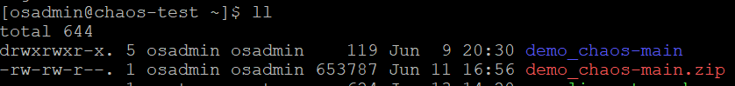

1. You will get below files once you Unzip and go to demo_chaos-main folder

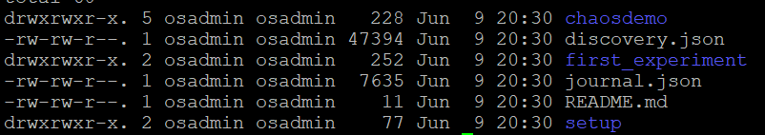

1. Now to setup go to setup folder and run 1_app.sh

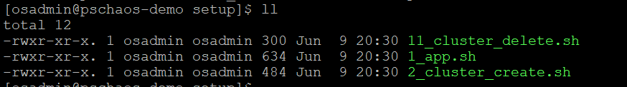

This is going to install the libraries and dependencies, along with docker , azure cli , kube8 etc

1. Once you run the above script you will see 2 files added to your folder

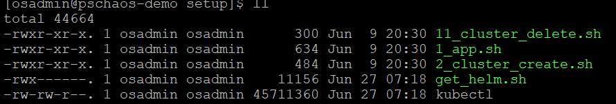

1. Now run cluster create script to create the cluster
2. 

Copy the link and code from above in a browser

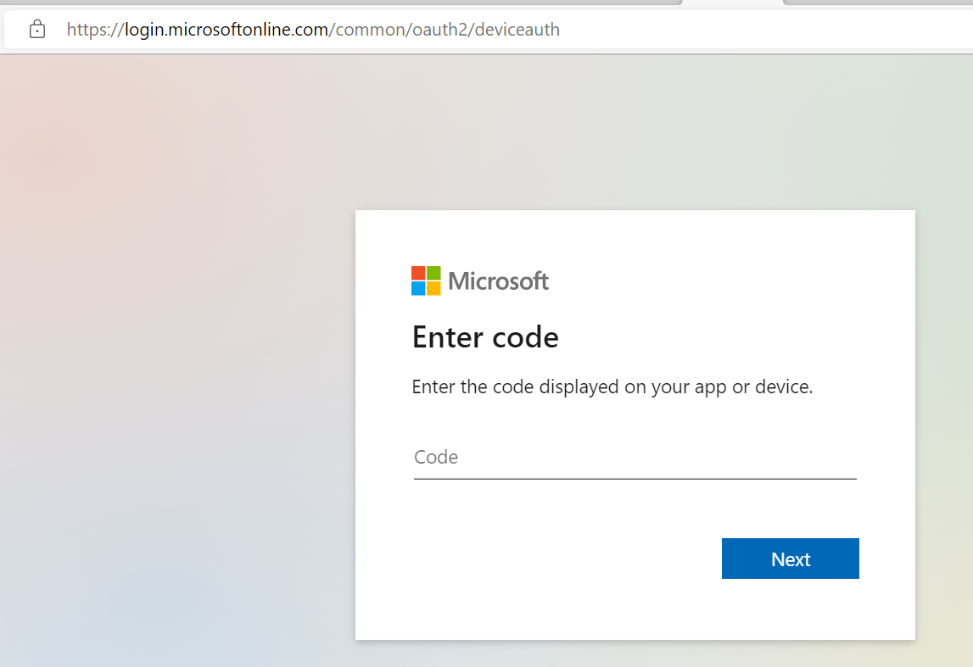

Sign in from your Microsoft account you used for Azure login

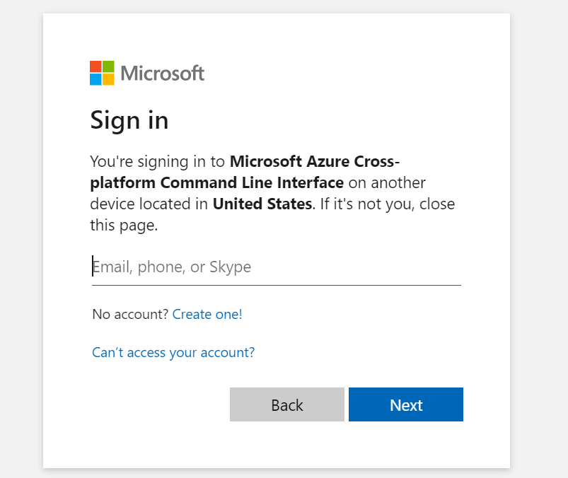

Click Continue

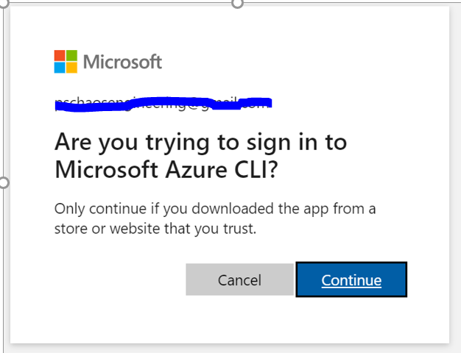

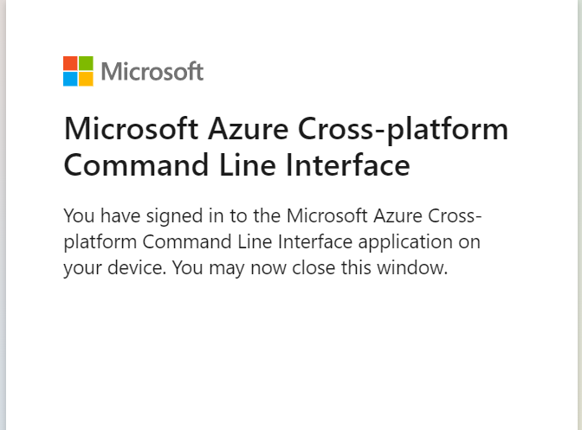

Once you are done with login you will see that script will start running further on the VM and start creating the cluster

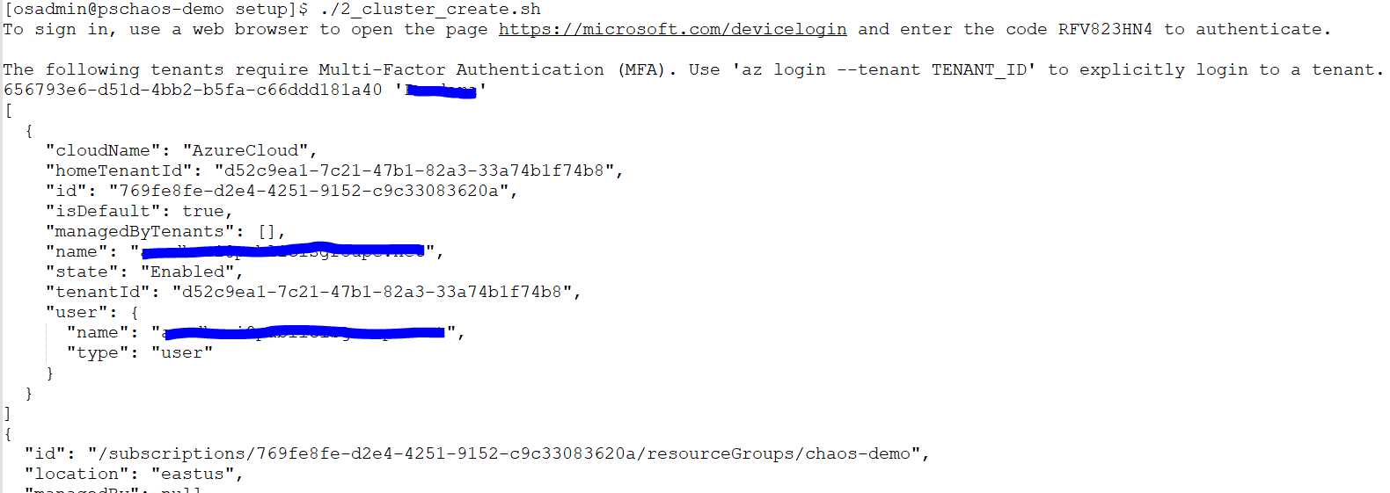

Full output is in github file cluster-create-output.txt

Once the script runs successfully you can see the nodes created

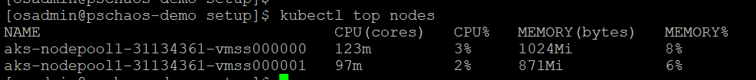

Sign Up for gremlin dashboard , go to the URL app.gremlin.com/signup using the details asked

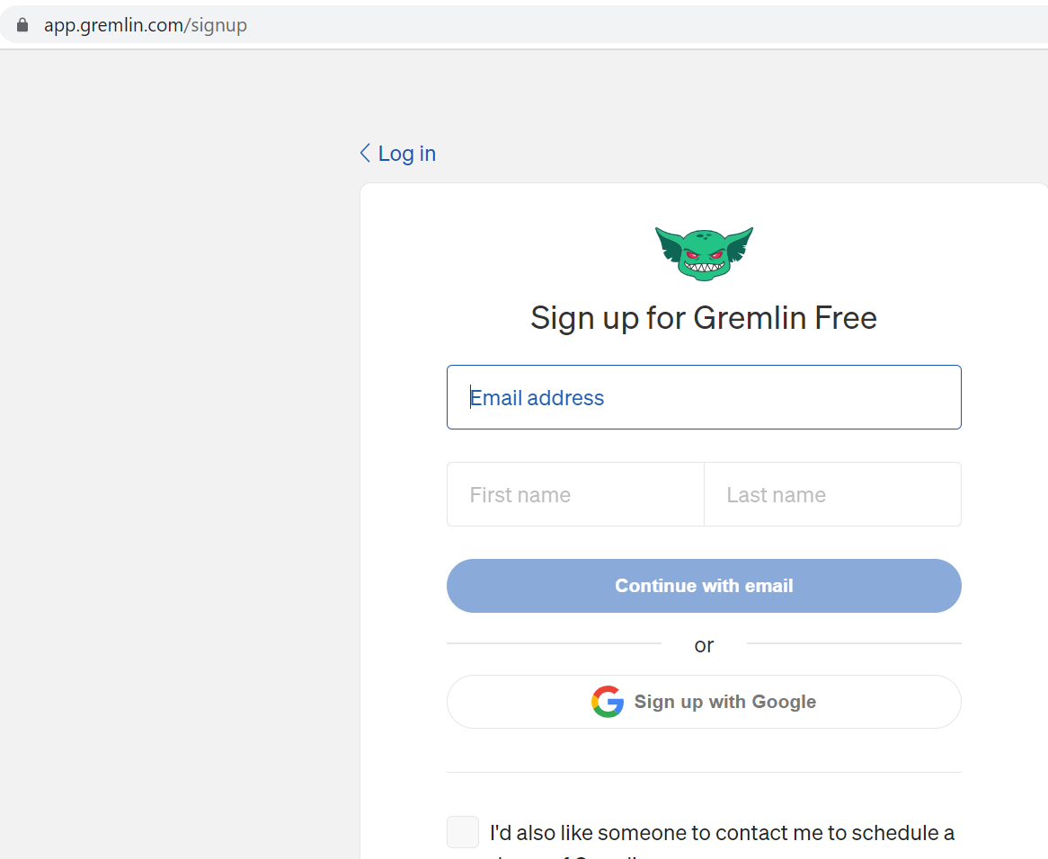

Once done get the below details which will be needed in the next script we run on our VM to setup gremlin

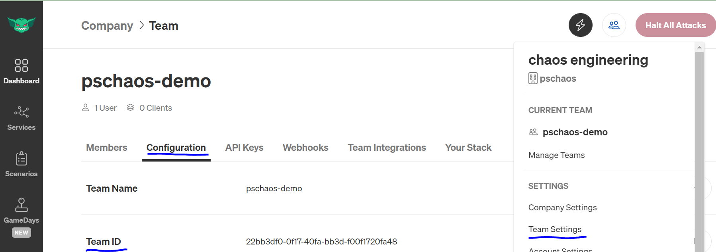

Now run the gremlin_setup.sh after making required changes like teamID , secret, (script uploaded in github)

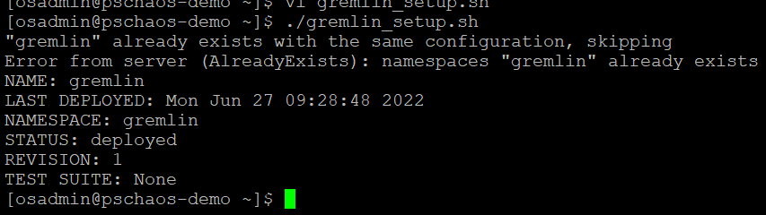

Now you will be able to see the targets (nodes ) in the gremlin dashboard and run experiments on them

In gremlin dashboard

